Monthly Report Submission of HVS Subsystem

Anish V R

*Department of Electronics and Communication Engineering*

*Manipal Institute of Technology*

220907748

Anish7.mitmpl2022@learner.manipal.edu

***Abstract*—This monthly report offers insights into battery and motor assembly operations, focusing on the transition from 96V to 48V systems. Throughout the period, technical hurdles were encountered continuously from the start of the month to the end. I tried to use the old compage 1kw motor and old Kelly controller, but I have continuously seen with issues with those system together even when the harness and other systems where correct. So I have changed the system to a Chinese motor and controller which is for the short time fast replacement for the bike launch and this Report will distinguish the issues and the future plans from my side on the HVS and LVS side .**

1. INTRODUCTION

In the first week of January, I have convinced everyone enough to cut the battery pack after a very long of arguments and disagreements. The whole team accepted to cut the battery pack into two. But the battery pack was in configuration of 27s in which one array was 14s and 13s where I have cut the battery pack into two with the help of Jishnu into 14s and 13s. This 14s battery array was cut into 13s because of the unavailability of 14s battery management system. At the time we were done charging it. We got a 100A and 50A BMS from Dally through Robu. I have wired the whole battery pack but due to the unavailability of another contactor couldn’t charge the battery pack. But we have ordered one now from darshan recently and will be in use when we get it. After facing issues of not discharging and charging the battery pack with the BMS I couldn’t figure out whether the BMS is working or not because what we ordered was smart BMS but we

got BMS which doesn’t show any outputs so have to check each parallel cell output manually during and these data’s were written on the board so that we can verify the rate of discharge and whether it is cell balancing or not. As we didn’t get the data from BMS couldn’t figure out the SOC (state of Charge) , Discharge Rate , Each cell pack Voltage, Battery Temperature and couldn’t add discharge control and charge control because of this there was no failsafe’s added to the battery pack. I also faced problems with Anderson plugs which are used to connect battery pack with controller because the Andersons which we had could handle only 50A at its max discharge. So we have ordered 120A rated Andersons and changed the whole harness according to the rating by changing the wire to 16sq mm.

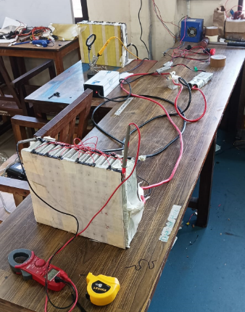

Fig 1. Wired 13s battery pack with BMS and connected to charger

The bikes battery which is mounted now into the NOVA is not properly insulated and we have to ground the whole battery pack which is indeed not done because of not using a case in this time period. In the second battery pack I have decided to add a contactor and a modular way to remove the BMS so that we can try to use the other 100A bms into it.

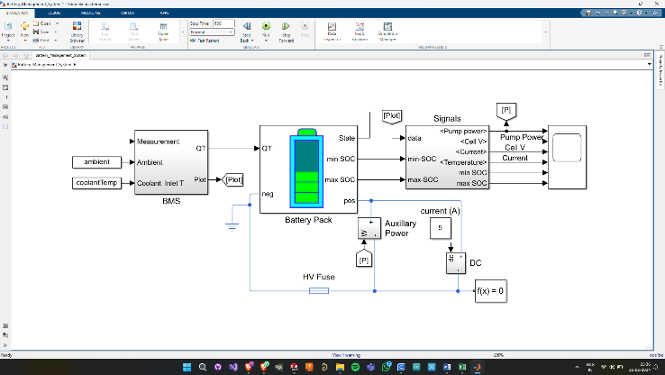We were facing big issue in the heating of the controller which we got from robu because we gave to much load pressure to the axle because of the 520 chain it started taking the maximum amount of current from the battery through controller. The temperature of the controller went till 72degree Celsius which was not good for a very long run. Tried to add a DC fan which works on the secondary 12v AMRON battery which we got from TMR but unfortunately me and jishnu added 4 fans which was rated 1.2A,0.4A,0.5A,0.5A and even a LED strip was even added with the contactors 12v supply which drank a lot of current which made our whole train to stop because of adding a lot devices to it. We also faced charging the 12v battery pack so got an Bosch C3 charger from TMR to charge it as well.

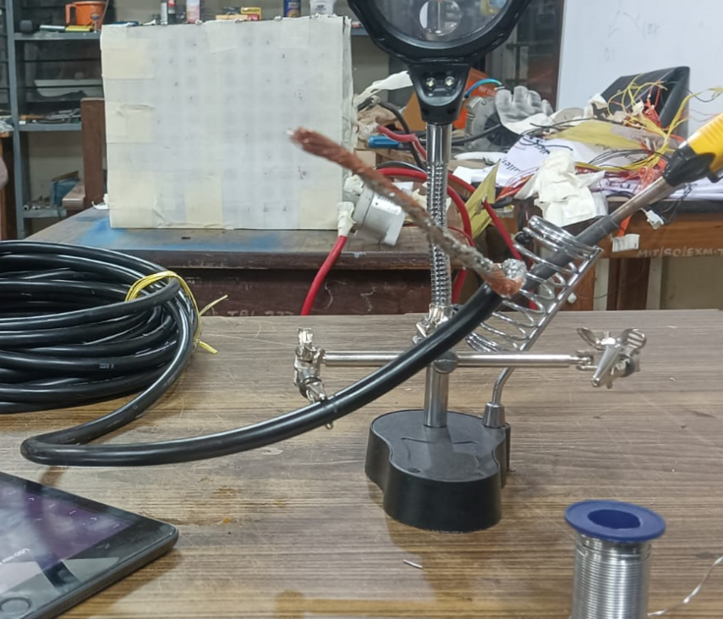One more big issue which I faced was parallelly connecting all 11 cells together to the of the Anderson through contactor and negative to the BMS. It must be connected through a fixed busbar so that it would have easily don

Fig 2. 25sqmm wired made into two to be connected with the +ve and -ve of battery

After NOVA:

For the next bike I have planned on working with pouch cells while making the battery pack inhouse by making a compression pack. So, to make the battery pack must start making a 12v pack then 24v and 48v and then 96v. So, a 50Ah 3C pouch cell cost around 2800 rupees and to make the whole 102.4 V battery pack it would cost around 89,600 and must make compression pack.

And for the next battery pack I wanted to make a modern PCB array for the power distribution system and integration of BUSBAR with it.

And I have completed my whole simulation of the Battery pack management system in MATLAB with the help of simscape modules which are present in their MATLAB portals